





National Cyber-
Physical Infrastructure

Future Opportunities Plan 2025

March 2025

Introduction

Report summary
This report sets out a high-level, future opportunities plan for the development and evolution of Cyber-Physical Infrastructure (CPI) and related activities, strategies and policy in the UK. This extends beyond the current grant funding period of the National Cyber-Physical Ecosystem project over the past 18 months, to how we can build future momentum for the UK in this important area.
A key aspect of this report is to present recommendations from the wider National Cyber-Physical Infrastructure Ecosystem (NCPI), reflecting the insights from workshops, interviews and activities undertaken during the past year. We outline next steps for building national capabilities through CPI, emphasising the need for a cohesive approach that aligns with broader policy goals such as achieving net zero, enhancing infrastructure resilience, and strengthening sovereign capabilities.
Finally, recognising the transformative potential of CPI in addressing national and global challenges, this Future Opportunities Plan covers the steps needed to transition from ecosystem enablement and early-stage initiatives to sustained, nationally coordinated research and innovation activities that support longer-term objectives.

Role of the NCPI Partners
The NCPI programme was delivered by Digital Catapult, Connected Places Catapult through the Digital Twin Hub, and the High Value Manufacturing Catapult.
Through their neutral and independent role in UK innovation, the NCPI Catapult partners bring together networks across sectors, at the interface between supply and demand of cyber-physical systems. This offers industry leadership spanning SMEs, academia, researchers, large corporates, system integrators and platform providers, innovation centres and agencies, and policy makers to ensure a systems-based approach to cyber-physical system innovation.

2. Strategic context

What is Cyber-Physical Infrastructure?

A future enabling infrastructure that combines digital and physical systems to create seamless ecosystems of interconnected solutions across sectors, helping to solve systemic challenges and transforming the way we live and work.​
Cyber-physical systems bridge the gap between the physical and digital realms. By sharing data between physical systems and their digital counterparts, these capabilities generate valuable insights that drive decision-making. This process spans activities such as scenario modelling, cross-platform collaboration, optimisation, and even autonomous operations.
The adoption of such systems is growing rapidly, providing significant societal, environmental, and economic benefits in the short term. As network effects continue to expand, their impact is expected to become globally transformative over time. These systems encompass digital twins, simplified digital models, robotic and autonomous systems, and increasingly spatial computing or metaverse applications, underpinned by extended reality technologies.
Importantly, the value of individual cyber-physical systems is greatly enhanced when they are interconnected. Just as the power of computers and smartphones grew exponentially through their networking via the internet, the potential of cyber-physical systems will rise as their network effects expand. Imagine a future where urban traffic systems can seamlessly integrate with elements such as built environments, energy infrastructure, weather conditions, social dynamics, local policies, and even the vehicles themselves.
This interconnected ecosystem of systems could form a foundational 'cyber-physical infrastructure' for future products, services, and decision-making. These integrated systems, supported by architectures, tools, platforms, and data, would streamline innovation by providing essential building blocks that allow creators to design, test, build, and connect their solutions more efficiently.

Building momentum for forward-thinking innovation

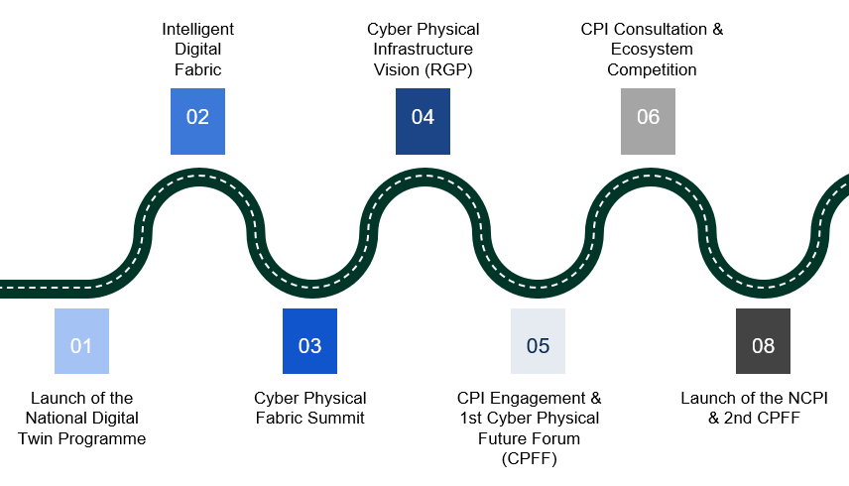

Since 2018 the UK has launched a series of cross-sector initiatives to lay the foundations for CPI, covering areas such as robotics, digital twins, and data standards. This included but is not limited to:

The Centre for Digital Built Britain created the Gemini Principles in 2018 – a framework of values (e.g. public benefit, purpose, trust, functionality) to guide the information management and governance of digital twins across the built environment and infrastructure. These principles remain key to CPI, ensuring a trusted and purposeful connection between physical and digital systems.

The Digital Twin Hub launched in 2020 to bring together the digital twin community to share knowledge and best practice across all areas of digital twin technology. The Hub is now based at Connected Places Catapult, where among other initiatives, it is taking forward the Gemini Principles via the Gemini Framework reference architecture, a methodology for the development of digital twins.
The Apollo Protocol launched by Institution of Engineering and Technology (IET) in 2022, addresses digital twin fragmentation in construction and manufacturing, creating a common framework for cross-sector data exchange.⁴ It supports the NCPI goal of cross-domain integration by enabling seamless collaborations across industries.
Intelligent Digital Fabric (IDF) developed by Digital Catapult in 2020 which explored how IoT, AI, 5G, and distributed ledger technologies into a seamless end-to-end digital platform.
The National Digital Twin Programme Isle of Wight Digital Twin Demonstrator was established to develop and showcase the practical application of digital twin technologies in policy feasibility testing, infrastructure resilience, energy management and support house retrofitting.
The UK Digital Twin Centre based in Northern Ireland – led by Digital Catapult backed by three industry partners Artemis Technologies, Spirit Aerosystems and Thales UK to help demystify, demonstrate and deploy digital twins by making them more interoperable, creating reusable expertise, methods and platforms and removing barriers to innovation and adoption.

The NCPI initiative was established to support the above activities, address systemic challenges, and collaborate across disciplines for innovation and R&D in technologies and sectors.

Industry and government visions have also emerged on this topic over the past 5 years

- The Robotics Growth Partnership (RGP)’s Vision for Cyber-Physical Infrastructure (CPI) in 2022, highlighting how integrating smart machines and digital twin technology could accelerate innovation and tackle major challenges.
- In March 2022 the government published the Cyber-Physical Infrastructure Consultation, which underscored the UK’s intent to secure a lead in cyber-physical systems and ensure that new tools – such as real-time simulations, robotics, and smart infrastructure – would drive economic recovery, resilience to future shocks, and progress toward net zero goals.
- In June 2023, the Department for Transport (DfT) Transport Research and Innovation Board (Board) published the Transport Digital Twin Vision and Roadmap to 2035’

Enabling Cyber-Physical Infrastructure Exploration

In 2022, the written consultation was conducted alongside online and in-person engagements to enhance the UK's understanding of the impact and potential of cyber-physical systems. The initiative also aimed to assess the value and possible approaches to developing a foundational Cyber-Physical Infrastructure that would unlock innovation. Through that work and feedback from numerous private and public sector organisations, the following challenges and opportunities were identified:
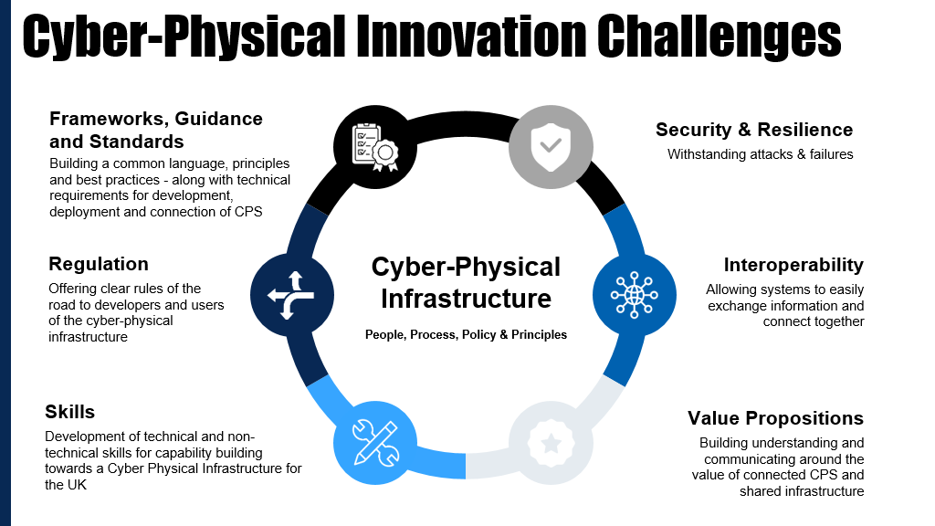

The result of this consultation was also the award of a £200k project, the National Cyber-Physical Infrastructure Ecosystem project by the UK Government’s Department for Science Innovation and Technology, jointly led by Digital Catapult, Connected Places Catapult through the Digital Twin Hub, and the High Value Manufacturing Catapult.

Its goal has been to continue to galvanise the wider landscape and build a multidisciplinary cyber-physical innovation ecosystem across the UK private and public sector.

3. The National Cyber-
Physical Infrastructure Ecosystem

Facilitating and enabling an impartial, mission focused and multi-disciplinary approach to innovation for connected cyber-physical systems.

Building on this momentum, the National Cyber-Physical Infrastructure Ecosystem over the past 18 months, has undertaken a range of key ecosystem mobilisation activities, propelled by the public and private sector with the goal of achieving the following outcomes:

NCPI Outcomes

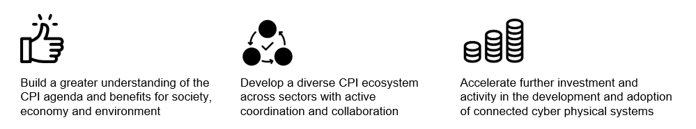

To achieve these outcomes we have sought to:
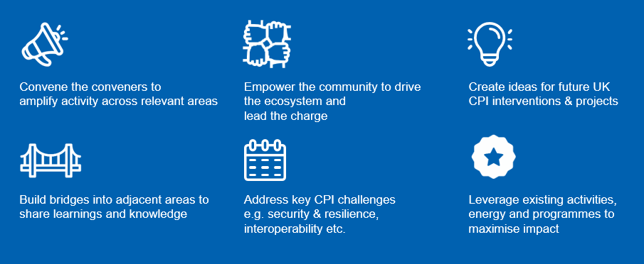

Through this we have undertaken the following activities:
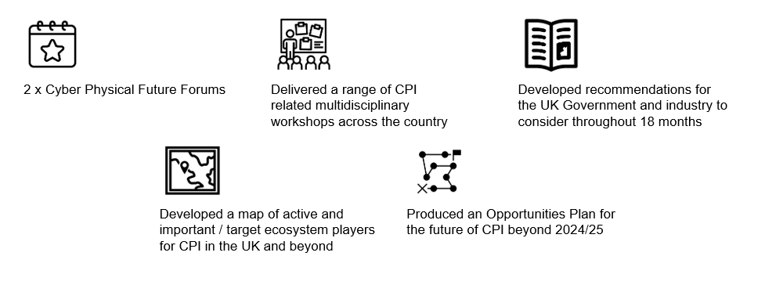
Simplifying the message
The NCPI project consortium produced its first report, Driving Cyber-Physical Innovation in the UK, in March 2024, defining the benefits and challenges of a cyber-physical infrastructure, and laying out a pathway of activities to identify and subsequently bring the ecosystem together.

This report considered policy and regulation, sovereignty, transparency and visibility as its guiding values. In specifying six enablers: 1. Security and Resilience 2. Interoperability 3. Standards, Frameworks and Guidance 4. Skills 5. Recognised Value Propositions and 6. Regulation, it created an approach for NCPI engagement and activities.

NCPI Ecosystem Mapping
The landscape for NCPI is broad and complex, which makes it challenging to find consistent information regarding existing innovations. This complexity, however, emphasis the necessity of understanding the current and future direction of innovation for UK's cyber-physical infrastructure, supported by an evidence base to inform future decisions. To achieve this, supported by ecosystem members, interviews and specialists from across DSIT and various research councils, an information pipeline was established to analysis available information from the ecosystem. This pipeline incorporated our own capture mechanisms alongside publicly available UKRI grants information.

To effectively understand the landscape, a taxonomic structure was established to categorise key challenge areas and identity the level of investment in each innovation domain. The developed pipeline processed innovation project information, leveraging the HQDM ontology by Matthew West to model research projects, subsequently producing a series of graphs on a web user Interface. Due to the limitations in data quality available from the sources, the analysis was limited to keyword search within project titles and descriptions to generate line graphs and bar charts for each research area. A key finding is that greater emphasis on improving the quality of collected data would significantly enhance future analysis. This includes incorporating information regarding technology readiness level (TRL) to assess industry maturity and details on involved for horizontal innovation opportunities.
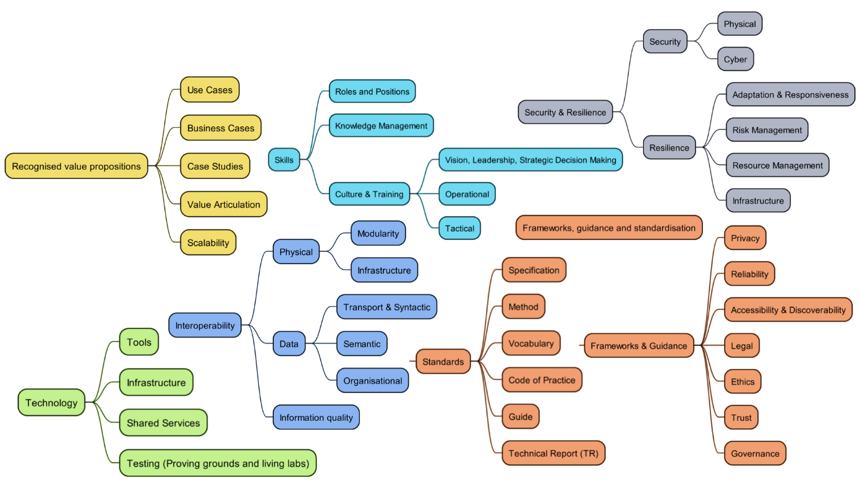

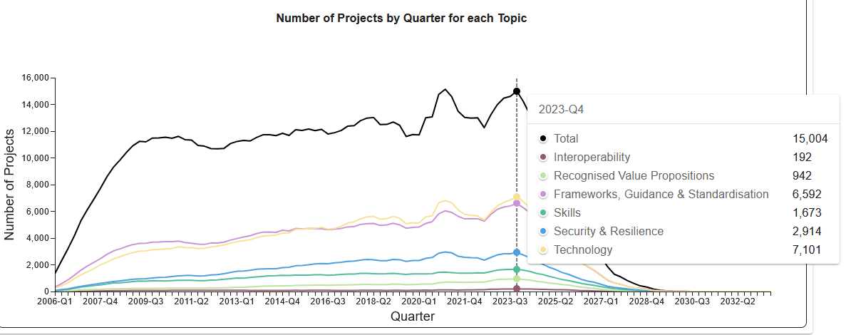

Accelerated Data Sharing Initiatives
In parallel with the NCPI project, the Catapult Network coordinated by Connected Places Catapult, has proposed the creation of a Data Sharing Infrastructure Hub to advance secure, efficient and ethical data sharing across sectors. According to Frontier Economics, using top-down modelling, this initiative will create benefits to the economy of up to £3,191 million (net present value) and deliver a benefit-cost ratio of up to 27.9.

Following extensive consultation with government and industry through a series of workshops and design exercises, a case has been developed to align with key national priorities, including the Industrial Strategy, AI Opportunities Action Plan, National Data Library, and the Technology Adoption Review. This was shared with the Digital Markets and Data Economy team at the Department for Science, Innovation and Technology to support proposals for future work in this area.

Workshops
The Catapult consortium convened a series of four workshops in 2024 to enable greater participation across the stakeholder community. These events allowed stakeholders to take a deeper dive into the enablers and the requirements across different parts of the cyber-physical infrastructure ecosystem, building upon the discussions from the Cyber-Physical Future Forum held in November 2023.

The four themes covered were:
- Cyber-physical infrastructure: Key challenges, May 2024
- Security and resilience, May 2024
- Interoperability, June 2024
- Frameworks, standards and guidance, July 2024

These workshops involved experts across advanced systems discussing priorities within their domains and identifying crossover. The workshops covered three of the enablers with skills, and value propositions as cross cutting themes for each event. Building on insights gathered at the workshops, NCPI published 19 recommendations relating to the key enablers for advancing cyber-physical innovation in the UK.

Communications, engagement
The project widened its reach and audiences using a range of communications channels (web, social, emails) made available by the consortium, shared news, event summaries and project outputs including reports on a bespoke NCPI website hosted by the Digital Twin Hub.

It communicated its key messages using a strong and recognisable government brand identity and a full range of branded marketing materials, used in all external communications.

NCPI in numbers

2732 visits to www.ncpi.org.uk
481 LinkedIn followers
250+ attendees across 2 Cyber-Physical Future Forums
160+ attendees across 4 workshops
920+ Driving Cyber-Physical Innovation in the UK report downloads
960+ Workshop recommendation reports downloads

4. Recommendations from the NCPI Ecosystem

Recommendations overview
Ecosystem activities focused on the following enablers from the government consultation.
- Overarching challenges and opportunities for the development and deployment of connected cyber-physical systems and cyber-physical infrastructure capabilities
- Interoperability between cyber-physical systems
- Security considerations for a future cyber-physical infrastructure
- Regulations, standards and framework requirements for a future cyber-physical infrastructure
- Skills and talent development in connected cyber-physical systems development and integration
- Novel value propositions and business models for connected cyber-physical systems and cyber-physical infrastructure
Through workshops, interviews and other activities, the NCPI ecosystem developed the following 19 recommendations for policymakers, regulators, and innovators to consider through the Invest 2035 industrial strategy and future cyber-physical related innovation activities in the UK.
- Overall Guidance for CPI
Embed Resilience in Infrastructure: Future infrastructure projects must mandate cyber-physical infrastructure components from the outset and critically within procurement activities to enhance security, operational value and overall adaptability.
Support Long-Term Innovation and System Design: Build frameworks for distributed and federated data ecosystems, whilst avoiding compromising shortcuts towards broader long-term objectives.
Establish Clear Standards for Interoperability: Develop and mandate minimum interoperability standards across physical, digital and organisational aspects, to ensure systems and technologies can work seamlessly together.
Prioritise Clear and Enforceable Regulations: Regulations, especially personal and sector-specific, should be unambiguous to universally ensure testable compliance.
Encourage and Regulate Data Sharing: Promote data sharing frameworks that can demonstrate and articulate the value of shared information while addressing legal, contractual, and governance challenges fostering collaboration between sectors.
- Interoperability
The lack of standardised mechanisms for sharing data and models poses significant challenges, as stakeholders have diverse needs and purposes. Effective collaboration requires addressing questions about what data to share, with whom, and under what conditions, while balancing open-source and private systems for flexibility and integration. CPI development is also a socio-technical challenge, demanding collaboration between government, industry, and academia alongside legal, regulatory, and commercial frameworks to align efforts. Interoperability also faces obstacles from legacy systems and fragmented local models that are difficult to integrate. A federated approach—enabling interoperability at the sensor level and for data sharing without centralising control—will be essential, potentially supported by common standards or protocols.
Recommendations
Incorporate interoperability requirements into Government procurement processes (aligning with Interoperable Europe Act which has been adopted by the European Commission to improve levels of interoperability across the public sector in Europe). Improving interoperability across the public sector will have a ripple effect of improving interoperability across the economy. The work can be approached in phases and should be further scoped and explored.
DSIT should seek to provide funding and governance commitment to develop a data sharing infrastructure for both public and private sectors across the economy. Mapping current best practice will form a key part of the work.
Create a pro-innovation regulatory framework. Set up a cross-sector digitalisation body to govern data sharing infrastructure and the application of common data rules across sectors. There is also a need to put greater effort and resource into coordinating the approach of existing economic regulators to data and AI.
Set up a UK Centre of Excellence or Data Sharing Hub to lead and convene across industry, including SMEs, and academia to combine frameworks, share learnings, collaborate internationally and promote best practice and skills across public and private sectors. Establish existing models and reports that support this through research or interviews.
Fund research on how interoperability can support AI, for example how data interoperability is a key enabler to accessing data for AI. Fund research on how AI can support interoperability (for example Digital Catapult’s AI Interoperability Flagship which is exploring how AI can help to automate interoperability between systems) initially using training data.
- Security and Resilience
CPI offers a transformative opportunity to enhance security and resilience through technologies like self-healing systems and digital twins, which enable exception modelling, continued operation during compromise, and strategic responses to threats. Interoperability models must be designed to maintain functionality during partial system compromises, proactively addressing risks such as cascading failures and adversarial vulnerabilities to ensure CPI delivers secure and resilient outcomes.

Recommendations:
Integrate Cyber-Physical Infrastructure Security approaches within education: Mandate CPI and cyber-security training in degree/apprentice level and workplace to address training gaps utilising NCSC/NPSA programmes where appropriate.
Universal cybersecurity regulations: Apply cybersecurity regulations uniformly across all sectors and ensure consistent security standards. The uniform application of cybersecurity regulations can be improved through the creation of case studies within each sector to share learnings rather than a siloed approach.
Promote R&D into CPI: Invest in cross-tech pollination programmes that lead to innovative solutions and support R&D to mitigate risks in emerging technologies (rather than singular tech focus areas)
Support public awareness campaigns: Launch campaigns to increase public awareness of Cyber-Physical System and Cyber-Physical Infrastructure threats to foster a culture that security and resilience is as fundamental as health and safety.
Resilience testing: Enhance and support comprehensive resilience testing of critical systems within Cyber-Physical Infrastructure, including regular testing cycles. Foster collaboration and information sharing.
- Standards and Frameworks
Developing standards is crucial for enabling interoperability, data sharing, and security within CPI, ensuring diverse stakeholders and technologies can collaborate through a common language. These standards must be agile and adaptable, evolving with technological advancements through approaches like active feedback loops or high-level principles.

Standards need to be inclusively and collaboratively developed to avoid dominance by single players and to ensure SMEs can engage effectively. International alignment is also key, as common standards open opportunities for living labs where technologies can be tested and refined in real-world contexts, thereby ensuring relevance, and avoiding the risk of stifling innovation or investment.

Ensure appropriate levels of governance, trust and ethical use are in place for early adopters of CPI. This should include increased coordination of current regulation, ensuring best practices are adopted when information is used to manage critical environments.
Standards organisations should convene, publish and adopt early vocabulary through ongoing engagements to lower barriers to entry, chiefly towards more difficult concepts around security and interoperability. Existing standards should always be utilised, especially for significant pre-existing sources around cyber-physical systems and infrastructure.
Distributed use cases must be defined by the ecosystem and explored highlighting differences to existing practices. In particular, industrial use cases that would drive early adoption towards market readiness. These should at minimum cover: future roles and responsibilities of users and operators, failure modes for security and resilience, and the benefits of having interoperability.
Infrastructure component boundaries must be standardised by technology providers for regulatory bodies to enable compliance through interoperability. This aids collective technology benefits in supporting their clients within the ecosystem.

5. A vision for future opportunities in Cyber- Physical Infrastructure

Establishing Pillars for Future NCPI Foci

Central to the future vision for a national cyber-physical infrastructure capability are the following:

- Further Cyber-Physical Infrastructure Ecosystem enablement
- Impact-driven Cyber-Physical Future Innovation and R&D

Cyber-Physical Infrastructure ecosystem enablement

Ecosystem enablement focuses on continuing to create a cohesive identity for CPI and fostering collaboration through platforms like the Cyber Physical Future Forums and workshops, bringing together stakeholders from diverse sectors, enabling alignment on shared goals, and amplifying the impact of existing initiatives. Communication of key messages is also vital for the growth of CPI, as we saw from the workshop series from the summer of 2024. Continued ecosystem activities should be encouraged between initiatives to find a common purpose and align around key frameworks and approaches.

Impact driven cyber-physical future innovation and R&D

Targeted innovation and R&D activities in Cyber-Physical Systems will provide practical resources, including toolkits, frameworks, use cases, and value propositions, to accelerate the adoption of CPS across sectors. This Future Opportunities Plan seeks to highlight CPI’s potential to support government priorities, including enhancing infrastructure resilience, driving productivity, and enabling innovation in areas critical to the UK’s future economy. By breaking down silos between sectors through R&D and innovation, any future Cyber-Physical Infrastructure capabilities will be able to deliver integrated solutions that align with the UK Government’s growing vision for a systems-based approach to innovation.

By building on the momentum of established programs and aligning with the UK Industrial Strategy “Invest 2035”, the following section of the report sets out several key initiatives the consortium recommends to build the future for NCPI. These ideas are both proposed, emerging and at the ideation stage. Cyber-Physical Infrastructure can be, through a range of key interventions, the systems-based approach that both the public and private sector can use to establish scalable innovation for a cyber-physical future in the UK.

Recognising that digital twins, data sharing infrastructure, and common frameworks for security, interoperability and innovation will be a transformative enabler of economic growth, societal resilience, and environmental sustainability, CPI can help ensure that the UK’s industrial and innovation ecosystems are equipped to thrive in a rapidly evolving global landscape with increasing fragmentation.

The following areas have therefore been identified as near-term opportunities to help sustain momentum of a national Cyber-Physical Infrastructure and continue to build the ecosystem whilst also driving impact through R&D.

Data Sharing
The National Cyber-Physical Infrastructure ecosystem throughout its engagements with the wider landscape in the past 18 months has received a persistent and consistent call to arms on data. To tackle systems-based challenges in the development, interoperability, security and scalability of cyber-physical systems – we first have to address the fundamentals of data sharing and the infrastructure that enables data sharing to ensure that cyber-physical systems can be developed, adopted and connected more easily. This can be achieved through a techno-social capability, that explores not only the technical barriers to data sharing but also addresses many of the underlying the breakdown of barriers between systems and systems of systems.

But despite this loud call to arms on data sharing across the public and private sectors, the current data-sharing landscape is fragmented, siloed, and ill-equipped to support the demands of a deep tech enabled cyber-physical future.

Key challenges include:

Fragmented Data Ecosystems: Many organisations in general, but particularly those working with technologies that interface between the physical and digital domains, tend to operate within isolated data structures, limiting collaboration between end users, sectors, innovation suppliers and infrastructure providers. This lack of integration creates barriers to seamless data sharing, reducing the potential for collaborative growth and the tackling of systemic challenges / opportunities.

Inconsistent Standards and Frameworks: The absence of unified standards, including ontologies and taxonomies, poses significant challenges for scalability and interoperability between cyber-physical systems. Developing consistent frameworks is costly and inefficient, making it difficult to establish reliable, broad-scale data-sharing systems.

Outdated and Incompatible Infrastructures: Many organisations still rely on legacy systems that are not designed to meet the needs of modern data-sharing requirements. The persistence of outdated infrastructure hinders technological progress and the ability to capitalise on new digital advancements.

Security Concerns: Insufficient governance and security frameworks undermine public and organisational confidence in data sharing. Issues related to data integrity, auditability, and privacy preservation are prevalent, with siloed approaches often resulting in repeated security breaches. The rise of quantum computing could further exacerbate these challenges, creating even more significant barriers to digitalisation.

Missed Opportunities: Without addressing these challenges, the UK's ability to fully leverage emerging technologies, such as AI, realise climate resilience and decarbonisation strategies, and improve public services, will be hindered and slow the progress of growth and impact against the Government’s 5 missions.

Interventions in data sharing are therefore essential to unlock the full potential of digital systems and realise their long-term benefits.

Recommendations for Data Sharing:
Establish a Data Sharing Infrastructure Hub that can bring together key stakeholders across the UK and across sectors – led by an independent set of organisations across sectors such as the Catapult Network.
As part of this hub, address and build out insights for future data sharing innovation across the UK with a particular focus on the data interface between digital and physical systems.
Establish a Data Sharing Deep Tech Experimentation Programme. This should explore the use cases of AI, distributed ledger technologies, and other privacy and security enhancing technologies that explore identity, authentication, authorisation, data preparation, data analysis, data or information transportation / secure channels, standardised data formats, messaging protocols and data endpoints.
Explore how data sharing infrastructures for connected cyber-physical systems and a future cyber-physical internet can be built and considered as part of a digital critical national infrastructure. This should look to leverage the private sector, but be built with public purpose with key principles, protocols and innovations set out and adhered to that ensure sovereignty and resilience in the UK.
Ensure the development of the UK Government’s National Data Library incorporates considerations around the common building blocks for innovation and R&D in cyber-physical systems – particularly where it relates to national infrastructure.

Cyber-Physical System Living Labs
To move from pilots and test environments to real world scalability and tackle systemic challenges and opportunities for the UK, it would be valuable to create a set of living labs for innovation that accelerates the time to market for new to solutions, supports the rapid development of solutions and crowds in multidisciplinary companies, investors and innovators across key areas. These living Cyber-Physical Living labs as proposed and championed by the Robotics Growth Partnership, have in the past 18 months started to be explored more meaningfully in other areas to create a lasting footprint of modular and flexible multi technology test, develop, deploy, connect and scale cyber-physical systems for the benefit of the UK.
Throughout this period there have been valuable discussions around a range of future facing R&D and living lab environments including but not limited to:
Spatial Computing: A Cyber-Physical Future Living Lab
With future metaverse and spatial computing capabilities evolving rapidly, discussions and interviews have highlighted the importance of a multidisciplinary living lab for spatial computing that will crowd in creative technology solution providers such as games companies, 3D designers, and extended reality innovators, alongside end users across key sectors, regulators, standards agencies, policymakers and infrastructure / hardware providers to look at the future potential of these technologies, their interoperability, the link to digital twins and their value as a general purpose capability for a cyber-physical internet. It would be valuable for the UK to consider its global role in shaping any future cyber-physical and spatial computing capabilities – building on our strengths in the areas mentioned above.
To do so, and crowd-in investment, we would recommend the following:
Establish a Spatial Computing and Future Internet Living Lab and Technology Access Programme. This should seek to make the UK a lightning rod for international investment in this growing area and ensure that a range of cyber-physical applications and new human machine interaction tools and creative technologies are tested in real world environments to explore what future innovation, safety, security, and interoperability should look like to inform new business models, the underpinning infrastructure and enable content creation. This living lab would be an R&D environment and safe space to explore the key aspects of developing a deploying a complex set of connected cyber-physical systems, data architectures and networks.

Advanced Manufacturing and Defence: A Cyber-Physical Future Living Lab
The development of a coherent set of standards and best practices can be likened to many other engineering challenges. A core physical space as a living lab that continually develops, and tests cyber-physical components would bring together working prototype systems. Components would be developed and tested individually by different sub-teams producing real early prototypes. This would generate the understanding that paves the way for refined coherent solutions.
Prototypes need to be tested in end-user communities, where they are risk-free and then free to make use of these developmental systems should they wish. A core living lab will aid decision makers in any associated early-adopter risk/reward analysis decisions within a space where defence-industrial and industrial-industrial can collaborate outside of commercial constraints and commitments.
To do so, an enabling experimentation considering of the following is recommended:
Establish a cyber-physical system living lab for advanced manufacturing and defence.
This should seek to ensure that all development interactions are built upon robust, data-centric digital foundations, developing appropriate software tools, enhanced user experience, and comprehensive education within a collaborative "live" environment. It will feature digital tooling that facilitates seamless interaction between diverse users and connects end-users with industrial proprietary modelling and simulation environments. This will enable whole-life asset feedback and parallel co-development activities, where models, requirements, and capabilities can be dynamically modified through a holistic team approach.
This collaborative methodology will improve operational, design, and strategic risk trade-offs serving as a practical experimental development platform. It will be underpinned by academic rigor, actively developing tools, processes, and eventually standards when proven by advanced trials as a socio-technical approach.

NCPI Ecosystem - Existing Areas of Alignment
UK Digital Twin Centre
​The UK Digital Twin Centre (DTC), delivered by Digital Catapult and funded by the Belfast Region City Deal and Innovate UK, opened in early 2025 in Belfast City Centre. This open-access facility aims to accelerate the adoption of digital twin technologies across various industries by providing access to cutting-edge tools, reducing development costs, and enhancing workforce skills. By fostering collaboration among academia, industry, and the public sector, the centre seeks to remove key barriers to innovation and promote cross-sector advancements. ​
A key feature of the centre is initial co-investment from major players such as Thales UK, Spirit AeroSystems, and Artemis Technologies. These collaborations are focusing on six use cases of digital twins in the maritime, aerospace, and defence sectors. By working closely with these industry leaders, the centre aims to showcase practical applications, value propositions and drive widespread adoption.​
By serving as a hub of knowledge and resources, the UK Digital Twin Centre is not only accelerating the adoption of digital twins but is also well placed to advance many of NCPI’s recommendations at the intersection between NCPI and digital twin technologies.
Apollo Protocol
The Apollo Protocol initiative catalyses information management practices across sectors, enabling evidence-driven decision-making through collaboration and technology. Its goal is to establish the formal communication between sectors, fostering economic growth, sustainable practices, and innovative solutions supported by federated evidence to inform policy.
The initiative presents a common approach to enhance cross-sector sector collaboration, enabling working together more effectively whilst opening new market opportunities. This evidence-motivated framework for industrial knowledge supports critical data-sharing practices, such as connected digital twins. Positioned as a key foundational part of the information management landscape, the Apollo Protocol champions collaboration to accelerate industry transformation.
In particular they call for: utilise the open Apollo Protocol approach and the Apollo Forum Methodology to accelerate innovation aligning with collaborative best-practices and engage with federated body of knowledges to develop robust, evidence-driven policies to tackle global challenge areas.
Digital Twin Hub
The Digital Twin (DT) Hub was established in 2020 by the Centre for Digital Built Britain at the University of Cambridge. Now housed at Connected Places Catapult, the DT Hub is a network for finding partners and collaborators. It is a place for learning and sharing experiences; for driving innovation, developing expertise and advancing the state of the art for digital twins. It identifies good practice, develops guidance and shapes standards on data sharing as well as showcasing the benefits of collaborative, connected digital twin endeavours.
Digital twins and interoperable, connected digital twins, are significant tools for fighting the global systemic challenges currently facing the world – challenges like pandemics, climate change and resilience. They are key enablers for ensuring better outcomes for people and nature through aiding a collaborative and co-ordinated approach to problem-solving. The DT Hub was established to support this socio-technical mission.
The next phase for the DT Hub is ambitious, as digital twin owners and builders look to support each other to develop increasingly advanced digital twins for diverse applications – joining up across sectors to follow the DT Hub motto: ‘learning by doing, progressing through sharing.’
Robotics and Autonomous Systems
There are a number of opportunities for NCPI’s priorities to be advanced within the UK’s robotics and autonomous systems ecosystem. One such initiative is the newly established Automated Distribution and Manufacturing Centre (ADMC). This centre will work with businesses to create and implement bespoke automation strategies and solutions that improve productivity and enable prosperity and growth around four “pillars” of activity - Research and Development; Prototyping and Proof of Principle; Showcasing and Demonstration; Skills and Training.
National Digital Twin Programme (NDTP)
The NDTP is a government-led initiative committed to growing national capability in digital twinning technologies and processes throughout the country, ensuring alignment with the broader strategic imperatives of the UK Government. As part of its mission to enable secure, scalable, and interoperable data-sharing, the NDTP has been funding and leading the development of an open-source data-sharing infrastructure known as “Integration Architecture” (IA).
The IA is designed to provide a trusted, distributed data-sharing framework, allowing organisations, to manage and exchange information securely while maintaining control over their own data. It lays out principles, standards, and technical guidelines governing data sharing, security, and interoperability across IA nodes and IA node networks. By establishing a distributed, interoperable, and secure foundation for data-sharing, the IA can play a critical role in supporting the long-term vision of a National Digital Twin (NDT). Further, by unlocking the ability to assimilate and exploit new and legacy information from multiple sources with differing levels of fidelity and complexity, the IA has the potential to harness artificial intelligence and other advanced technologies.
Developed collaboratively with other parts of government as well as industry, the IA is already being deployed, tested, and extended by organisations across multiple sectors. This work is vital to ensuring the IA remains adaptable, practical, and aligned with real-world needs.

Integrated Transport Network and Crisis Management
Research published by DfT in 2024 estimated that there are significant benefits in using Digital Twins to integrate different transport modes dynamically, such as combining road and air traffic management. Such a system of digital twins could enable better holistic use of the transport network, increase resilience towards planned or unplanned events (ranging from maintenance to crisis) and enable better cross-sectoral collaboration. DfT has also sponsored research to support the creation of such digital twins, including developing cross-modal ontologies and new methodologies in digital twins for crisis response and resilience.

