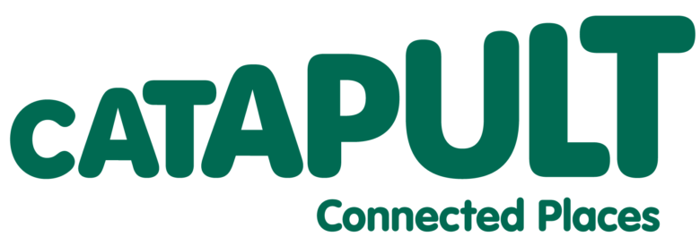

Connected Places Catapult
Invitation to Tender
Developing the Climate Resilience Demonstrator (CReDo) the Connected Digital Twin of Critical Infrastructure for Climate Change Resilience and Adaptation
CPC2022090
July 2022

CONTENTS

- SECTION 1 – INTRODUCTION & BACKGROUD
  - Company background and information
  - Approach

- SECTION 2 – TENDER PROCESS AND INSTRUCTIONS
  - Summary Contract Details
  - Definitions
  - Introduction
  - Tender Submission
  - Respondent enquiries and clarification
  - Respondent responses
  - Post-Submission Clarifications
  - Award Criteria Summary
  - Quality Criteria
  - Presentation
  - Legal Information

- SECTION 3 - CANCELLATION PROCESS
  - Right to Cancel
  - Right not to award a contract
  - Right to part award a contract or Multiple suppliers
  - Costs
  - Confidentiality

- SECTION 4 – TENDER EVALUTION PROCESS
  - Tender Evaluation Process
  - Marking Scheme

Appendices
Appendix 1 – Terms and Conditions
Appendix 2 – Specification
Appendix 3 – Response to quality evaluation criteria
Appendix 4 - Pricing schedule

SECTION 1 - INTRODUCTION & BACKGROUND

Company background & information
Connected Places Catapult is the UK’s innovation accelerator for cities, transport, and places. At Connected Places Catapult, we provide impartial ‘innovation as a service’ for public bodies, businesses, and infrastructure providers to catalyse step-change improvements in the way people live, work and travel. We connect businesses and public sector leaders to cutting-edge research to spark innovation and grow new markets. We run technology demonstrators and SME accelerators to scale new solutions that drive growth, spread prosperity, and eliminate carbon.
Our Focus
Connected Intelligence
The infrastructure that enables digital connectivity within and between places as well as the technology and intelligence that enables data-rich insights, modelling and analysis.
Climate Action
We convene the markets to spark disruptive innovation and scale up Net Zero and resilience technologies, by developing the business and operational case for adoption and deployment.
People’s Experience
Places prosper when they understand and design for the needs of people. Connected Places Catapult has access to a range of capabilities which help partners to understand changing needs and to design for experience.
What We Stand For
- We are human centred, solution-led
- We advocate for standards which enable interoperability, replicability and scale
- We work in partnership with others across the UK and beyond to provide access to R&D assets and deliver impact
- We support local economies and organisations by being present within them to embed and transfer innovation capabilities
- We are globally connected in order to stimulate demand for UK innovations overseas and create opportunities for companies to expand globally

Approach
This Invitation to Tender (ITT) is being issued as part of the procurement of delivery of a reusable data infrastructure for connected Digital Twins (referred to hereafter as the products and services) to be provided to Connected Places Catapult (CPC)
The objective of this ITT is to provide sufficient information for Respondents to:
- Understand CPC requirements and proposed procurement approach
- Understand the scope and nature of the products and service that they will contract to provide
- Assess their ability in bidding to provide this service
- Provide agreement and/or feedback on proposed approach to the management and governance of this service
- Provide agreement and/or feedback on proposed contractual terms and commercial approach
- Develop and price a proposed solution based on current available information in the format specified
Respondents’ compliance with the requirements and submission in the required format will enable CPC to carry out a fair and thorough evaluation of the responses. Please see section 2 for details of the instructions. Failure to comply with these instructions will invalidate the Respondents submission.

The Respondents attention is drawn to the principles and terms set out in Appendix 1.
Each Respondent must perform its own appraisal of all information and data provided by CPC in this ITT. The products and service that form the basis of this document have been documented to the best of CPC’s knowledge and are not warranted.
You are deemed to fully understand the procurement process CPC is required to follow the Public Contract Regulations (PCR 2015).

Section 2 – TENDER PROCESS AND INSTRUCTIONS

  - Summary Contract Details
Contract description | Connected Places Catapult (CPC) is working together with Anglian Water (AW), UK Power Networks (UKPN) and BT to develop a connected digital twin demonstrator that helps the cross-sectoral infrastructure network adapt to climate change and improve climate resilience.
Contract period | Sep 2022 – Mar 2023
contact point | Raj Ragiwala  raj.ragiwala@cp.catapult.co.uk
closing date | 19 AUGUST 2022 12:00 hours

  - Definitions
Closing date | The closing date for the submission of tenders being: 19 August 2022 at 12:00 hours
Contract | The contract will be entered into by CPC and the successful tenderer.
contract period | The duration of the contract will be: up to 7 months
most economically  advantageous | The tender which CPC has evaluated as demonstrating the best value for money, taking into account both price and quality of service.
services | The services and/or product to be supplied by the supplier under the contract
Supplier(s) | The tenderer(s) selected will enter into a contract with CPC
Tender | The proposal submitted by a potential supplier.

Introduction
Connected Places Catapult (CPC) is working together with Anglian Water (AW), UK Power Networks (UKPN) and BT to develop the Climate Resilience Demonstrator (CReDo). CReDo aims to be a connected digital twin of critical infrastructure that helps the cross-sectoral infrastructure network adapt to climate change and improve climate resilience.
CReDo showcases the advantages of combining data and insights across sectoral and organisational boundaries. The resulting improved coordination of operational and investment decisions, including inter- and intra-sector collaboration, will increase resilience against extreme weather events. At present this covers infrastructure across the water, energy and telecoms sectors, but the long-term ambition is to capture additional sectors, at a national scale.

Tender Submission

All documents submitted as part of your tender must be written in English and sent to Connected Places Catapult.

An electronic copy of the Respondents proposal should be submitted through the portal below.

https://procontract.due-north.com/Register
Responses will not be opened until the closing time and date for receipt of tenders. Please do not leave your tender submission until the final deadline as tenders received late will not be considered.

  - Respondent enquiries and clarification
The Respondents will be able to raise clarification questions. All questions concerning the tender must be made in writing via email and must reference the tender page number and section number. Questions should be concisely stated and be numbered in sequential order.
Questions must be submitted by 12:00 hours 11 August 2022 via the portal https://procontract.due-north.com/Register
Questions will be responded to within two days of receipt, by circulation of anonymised responses to all Respondents.
Any approaches to other members of staff, direct or otherwise in direct relation to this tender will result in exclusion from this process.

Respondent responses

Respondents are invited to respond to this ITT by submitting a detailed bid that addresses all the requirements set out in this document.
Each response should be submitted in the name of the Respondent who will be entering into any resultant contract with CPC. The bid must apply from the closing date for ITT bid submission and be valid for a period of twelve months. CPC may require the Respondent to extend the validity of its bid at any time prior to the contract award.
The bidders must also complete the Selection Questionnaire Document and return this with their ITT submission.

  - Post-Submission Clarifications
During the evaluation period, the Connected Places Catapult reserves the right to seek further information from the tenderers to assist in its consideration of the tenders; this may take the form of post-submission clarification meetings or written clarifications.

  - Award Criteria Summary
CRITERIA | WEIGHTING | DEMONSTRATED BY
Price | 15% | Price submitted by tenderer where the lowest cost tenderer shall receive 15% and all other scores shall be allocated according to their difference from the lowest price, using the formula.  15% x [lowest price of all tenderers/tendered price.] Abnormally low tenders may be rejected if considered to be too low to fulfil all the requirements of the specification.
Quality | 85% | Each criterion will be marked using a scale of 0-5 (as referenced in section 4.2)

  - Quality Criteria
Tender responses for quality criteria will be evaluated according to the table set out below.
Tenderers must enter their response to the below evaluation criteria in Appendix 3.
CRITERIA | SCORING (%)
Technical expertise and relevant prior experience | 50%
Appropriate and realistic project plan | 15%
Quality of the team | 20%
Proposed approach to long-term exploitation of results | 15%

  - Presentation
A potential shortlist of Respondents will be invited to make a presentation to introduce their company and present their tender response.
Connected Places Catapult will provide guidance where it considers it appropriate to do so to each Respondent ahead of this presentation as to any specific queries or issues to be covered in respect of that specific Respondents proposal.
Specific dates, times and locations for presentations will be advised later in the selection process and if possible, notified at least a week in advance. For now, Respondents should assume a one-hour slot, with formal presentations for around thirty minutes followed by questions and answers.
For each Respondent the senior manager that would be responsible for the contract is required to attend the presentations.
ACTIVITY | DATE
ITT Issue - ITT issued to respondents | 19 July 2022
Clarification Questions closes | 11 August 2022 12:00 hours
Respondents Proposals - CPC to receive responses to ITT | 18 August 2022 12:00 hours
Evaluation of Proposals - Review, score and evaluate proposals, including a credit check of potential suppliers. | 18 August 2022
Shortlist respondents & inform all respondents of results of selection process i.e.: successful and unsuccessful | 22 August 2022
Supplier presentation | W/C 22 August 2022
Tenderer Selection – Review and recommend preferred tenderer | W/C 29 August 2022
Management and / or Internal Board Approval | W/C 29 August 2022
Standstill Period Ends | 1 September 2022
Contract Awarded | 2 September 2022
Contract Commences (with respondent fully accountable for ongoing service) | 9 September 2022

  - Legal Information
The contractual terms are set out in Appendix 1. The contract will end 31 March 2023.
Tenderers may propose minor amendments to the contractual terms attached. If tenderers wish to seek clarification in relation to any provision of the contractual terms, they should do so by asking a clarification question and submitting that question accordingly. Tenderers should note that responses to clarification questions may be provided to all tenderers.

- SECTION 3 - CANCELLATION PROCESS

  - Right to Cancel
Connected Places Catapult reserves the right to terminate the tender process. This ITT does not represent a commitment to enter into any contract.
  - Right not to award a contract
Connected Places Catapult reserves the right to reject all tenders if none, in its opinion, adequately satisfies the requirements, or if Connected Places Catapult’s circumstances change. In such circumstances Connected Places Catapult may subsequently issue another ITT.
  - Right to Part award a contract or to multiple suppliers
Connected Places Catapult reserves the right to part award where some of the requirements are met and to more than one supplier where appropriate.
  - Costs
Respondents shall bear all costs associated with the preparation and submission of their tender and CPC shall not be responsible or liable for any costs or expenses regardless of the outcome of the procurement process.
  - Confidentiality
All communications issued by Connected Places Catapult to respondents must be treated as strictly confidential. Respondents shall not release details of such communications other than on an “In Confidence” basis to those who have a legitimate need to know or whom they need to consult for the purpose of preparing their tender. Under no circumstances may Respondents release any information concerning such communications for publication in the press or on radio, television, screen or any other medium. The content of the tender and the details of the evaluation of the proposals will remain confidential to Connected Places Catapult and its advisors who will comply with all relevant legislation. Should Respondents wish that any information supplied by them as part of this process not be disclosed because of its commercial sensitivity or confidentiality or otherwise, they must, when providing this information, clearly identify the specific information they do not wish to be disclosed and clearly specify the reasons for its sensitivity.
Please note that it is not sufficient to include a statement of confidentiality encompassing all the information provided in the response.

- SECTION 4 – TENDER EVALUTION PROCESS

  - Tender Evaluation Process
The evaluation process will follow the below stages:
Stage 1: Receipt and Opening
Stage 2: Compliance Check
Each tender will be checked for compliance with the requirements of the ITT and Mandatory sections of the Selection Questionnaire. Tenders which are not substantially complete or which are non-compliant with the ITT may be excluded from further participation in the evaluation process or, at the Catapult’s discretion, tenderers may be asked to provide clarification. In the case of the latter, a failure by the tenderer to provide a satisfactory response within the deadline specified in the request for clarification may result in disqualification from the evaluation process. Connected Places Catapult reserves the right to evaluate tenders before declaring them non-compliant.
Stage 3: Evaluation of Tender Responses
Price and quality evaluation will be carried out in accordance with the published evaluation criteria.
Stage 4: Score Review
Review of quality and price scores
Stage 5: Final Evaluation Report and Recommendation
A final evaluation report will be completed, recommending award.

  - Marking Scheme
0-5 | USING A 0-5 MARKING SCHEME
0 | Unacceptable Response – No information provided or response does not address the requirements.
1 | Poor Response- The response contains material omissions and/or is supported by limited evidence/examples. Major concerns that the tenderer has the potential to deliver/that they have failed to meet a reasonable standard.
2 | Fair Response – The response contains some omissions and/or is not well supported by evidence/examples. Some concerns about the tenderer’s ability to deliver/that they have failed to meet a reasonable standard.
3 | Good Response – There is adequate detail/supporting examples giving a reasonable level of confidence in the tenderer’s experience and ability. The tenderer appears to have the potential to deliver as required/has met a reasonable standard and there are only minor concerns about the tenderer’s experience.
4 | Very Good Response – The level of detail/supporting examples gives a high level of confidence in the tenderer’s experience and ability. The tenderer clearly has the potential to deliver and/or has clearly met an acceptable standard.
5 | Excellent Response – A comprehensive well evidenced submission, clearly demonstrating expertise and knowledge incorporating value added benefits/social value attributes and other points of innovation. The response is deemed to offer little or no risk and fully captures the understanding of the steps involved to deliver the aspects of the question posed, giving a very high level of confidence in the tenderer’s experience and ability.

Appendix 1: TERMS AND CONDITIONS
This contract will be on Connected Places Catapults standard terms and conditions and any special terms and conditions in respect to the lease of devices.
Please find attached as a separate document.

Appendix 2: SPECIFICATION

Introduction
Connected Places Catapult (CPC) is working together with Anglian Water (AW), UK Power Networks (UKPN) and BT to develop the Climate Resilience Demonstrator (CReDo). CReDo aims to be a connected digital twin of critical infrastructure that helps the cross-sectoral infrastructure network adapt to climate change and improve climate resilience.
CReDo showcases the advantages of combining data and insights across sectoral and organisational boundaries. The resulting improved coordination of operational and investment decisions, including inter- and intra-sector collaboration, will increase resilience against extreme weather events. At present this covers infrastructure across the water, energy and telecoms sectors, but the long-term ambition is to capture additional sectors at a national scale.
The first phase of CReDo was funded by a collaboration between CPC and the Centre for Digital Built Britain. CPC have taken over as the lead organisation for the next stage of development. In addition, CPC is the new home of the Digital Twin Hub, which is a multi-sector industry and Catapult Network partnership.
CReDo is entering its second phase of development. As part of this work, CPC is seeking a supplier to help deliver the data engineering and core functionality, including descriptive data visualisation, that is needed to scale up this connected digital twin. This will involve working collaboratively as part of the interdisciplinary project team, dealing with uncertainty, providing thought leadership around practical data standards and sharing, and creating innovative solutions to data problems.
The indicative budget for this work is £350,000 plus VAT. The indicative timeline is for work to start in September 2022 and finish by 31 March 2023. CPC intends to fund the CReDo project for the following 2 years.
The output of this work and all IP arising from it will be owned by CPC, with an intention to make it publicly available. Any background IP brought into the project by the supplier will remain the supplier’s. CPC welcomes indications of how suppliers intend to leverage the outputs of this work to support exploitation of their own IP.
Current state of CReDo
The first year of development laid down the foundations of the approach. The open-source codebase is available in the resources below. It relied on a knowledge graph as the underlying information integration mechanism. The knowledge graph used ontologies to represent the data in a way that enabled interoperability between the data and models within the connected digital twin. The Data and Analytics Facility for National Infrastructure (DAFNI) Platform was used for the runtime environment, which enabled modular and containerised workflows.
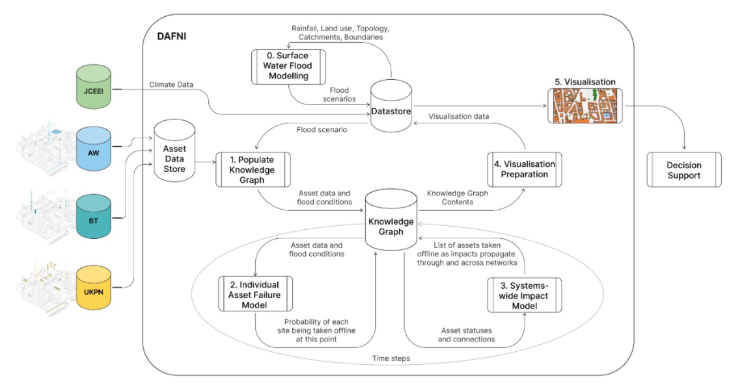
Figure 1: Illustration of present CReDo information flow.

Figure 1 provides an illustration of the information flow within the system. At a high level, the current workflow of credo consists of:
- Cleaning and ingesting data from the asset owner networks (e.g. asset id, name, location, type, connections, etc.).
- Representing the assets and their connections (e.g. substation A provides power to water pump B) using a knowledge graph.
- Using the results of hydrological modelling to simulate the impact of flooding on the states of all assets in the network. This includes failures directly caused by the flood, and failures resulting from cascading network effects (e.g. substation A is flooded, and so water pump B fails through a loss of power, even though B is not flooded.
- Visualising the results with a web-based geospatial application.
In addition to this there has been progress in developing:
- Probabilistic models for the failure of individual assets. These can account for additional failure information elicited from asset engineering experts, such as the chance that an existing backup generator fails.
- Algorithms to propagate the probabilistic failures through the network.
- Models for decision support.
Some relevant resources can be found on the Digital Twin Hub:
- Visualisation https://digitaltwinhub.co.uk/credo/visualisation/
- Overview Report https://digitaltwinhub.co.uk/files/file/142-credo-an-overview/
- Technical Reports https://digitaltwinhub.co.uk/credo/technical/
- Codebases https://digitaltwinhub.co.uk/credo/resources/technical/
Development team and environment
The supplier will be part of the core development team along with members of CPC and Science and Technology Facilities Council (STFC), which includes data scientists and strategists, data and software engineers, as well as product and project managers. The wider project team may include relevant academics and industrial experts, to be determined.
Future development will continue to use an open-source, modular and containerised approach to achieve scalability and interoperability with the broader digital twin ecosystem. The project will utilise a secure and private sandpit development environment. The data and Linux virtual machines will be hosted on STFC servers. It will not be possible to use third-party or cloud services to host the twin or data, such as digital twin / internet of things platforms. STFC engineers will support the supplier with security needs and setting up the development stack.
Core functionality development
Part of this development cycle is to build out the core functionality, which includes but is not limited to:
- Implement a scalable design that enables the inclusion of new types of assets, asset owners/users, failure modes, and weather events (not only limited to flooding). One of the core challenges is designing a system that can generalise to multiple climate models and their combined failure modes.
- Integrate probabilistic models of individual asset failure and algorithms for failure propagation, and codesign how probabilistic failure is reported to users.
- Investigate and implement resilience metrics such as those describing the criticality and vulnerability of individual assets, subnetworks and the network as a whole.
- Create data import and export functionality that uses practical data standards, such as industry standard schemas, to enable interoperability with internal user systems and the wider digital twin ecosystem. The internal CReDo data model does not necessarily need to use these schemas.
Use case development
In collaboration with the asset owners a use case has been finalised for the next development cycle. This use case focuses on future planning and reporting. The use case will help asset owners plan for the future by helping them to determine where there are vulnerabilities in their network, where they can invest in better precautionary and defensive measures, and where new assets should be developed. Note that due to the interdependent nature of infrastructure, the best investments may not be on their own network. The use case will also aid in asset owner reporting, either internally or to network regulators.
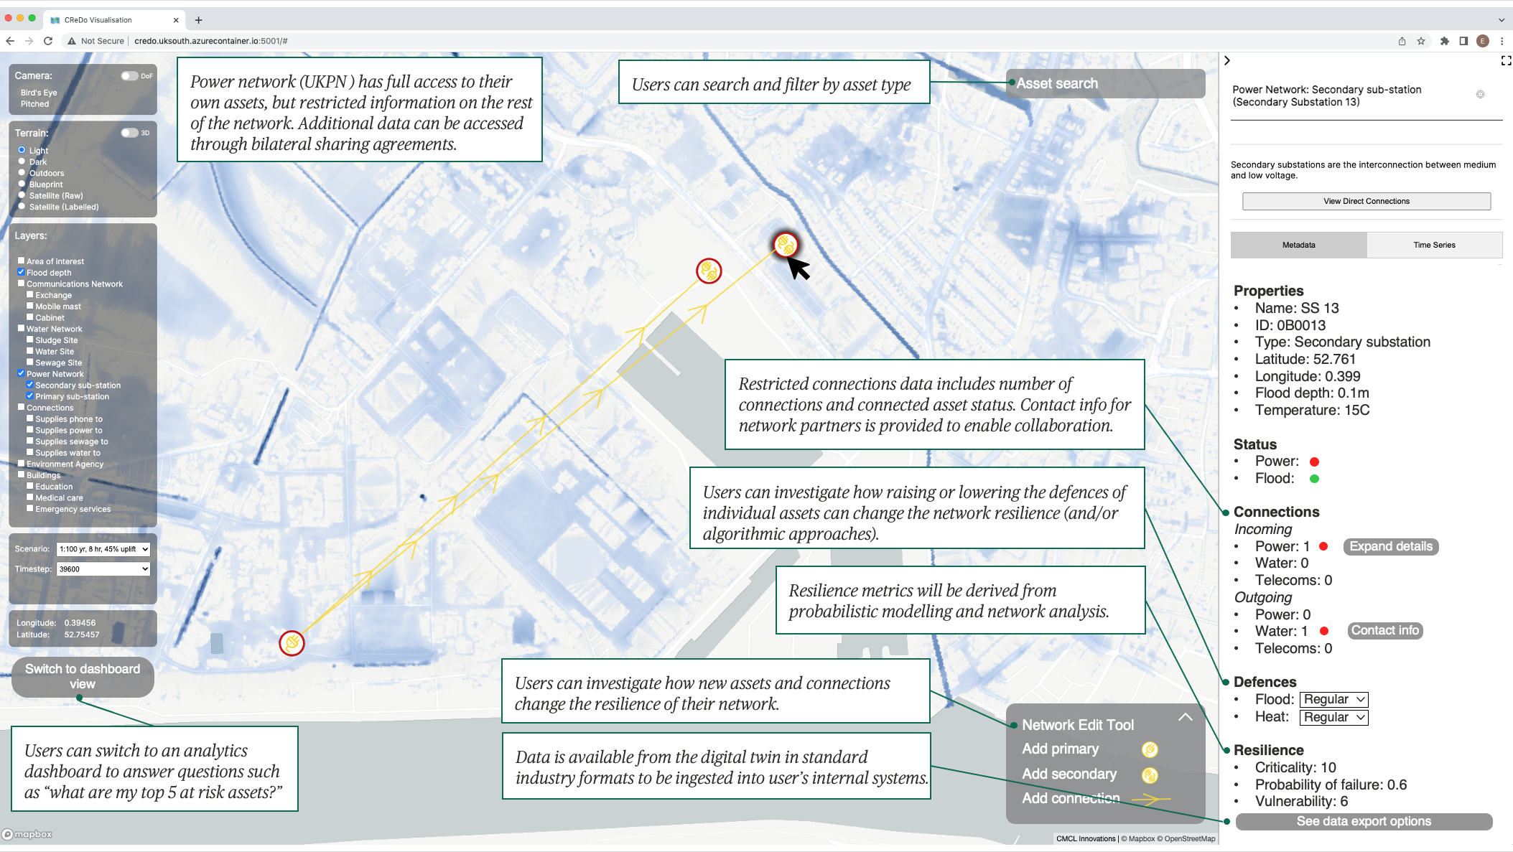
Figure 2: Illustration of potential features to be added to the geospatial visualisation.
This development cycle will focus on the specific use case, building out core functionality and enhancing the user experience. To this end, a number of new features have been shortlisted, some of which are illustrated in Figure 2. These include:
- Expressive visual and numerical rating systems to represent the state of an asset subject to weather events and cascading failures.
- Features to aid in planning, such as variable levels of assets defences, and network configuration tools.
- Utilise and embed new data sources as they become available, such as how assets support critical services (e.g. hospitals), or new asset types (e.g. roads).
- Upgrade the geospatial visualisation and create a new analytics-style dashboard visualisation to aid in the use case, and enable users to answer questions such as “what are my top 5 at risk assets?”
- Various user experience functionality including asset search and filtering, history, geographic selection, etc.
- User data management and administrator tools.
- Features to aid in reporting, such as economic benefits reporting.
Architecture development
Although great technical progress was made in the first development cycle, there were some blockers. One of the key challenges of the project is the controlled sharing of confidential asset owner data.
Intrinsically, the connected digital twin must combine aspects of the data to achieve a system of systems view and resolve the intersectoral cascade of failures. However, for the purposes of climate resilience and adaptation, a subset of this data is sufficient for any given user. For example, the owner/user of substation A needs to know that their asset provides power to water pump B, but it is not necessary to know all details, such as the location, of B. Likewise B need not know all details about A. The required shared data is context specific and use case dependent and will be referred to as ”need-to-know” data.
To overcome this challenge, the data architecture will be redesigned. This has been started at a high level, with the intention that significant room has been left for the supplier to contribute to the final implementation. An illustrative diagram of this architecture is presented in Figure 3. The new architecture will include a framework for permissions-based data access, or equivalent, for the system and visualisation/application. This framework should simultaneously accommodate both full and partial (need-to-know) data transfer and access. This framework should allow for bilateral data sharing agreements to expand inter-user data sharing beyond need-to-know data sharing.
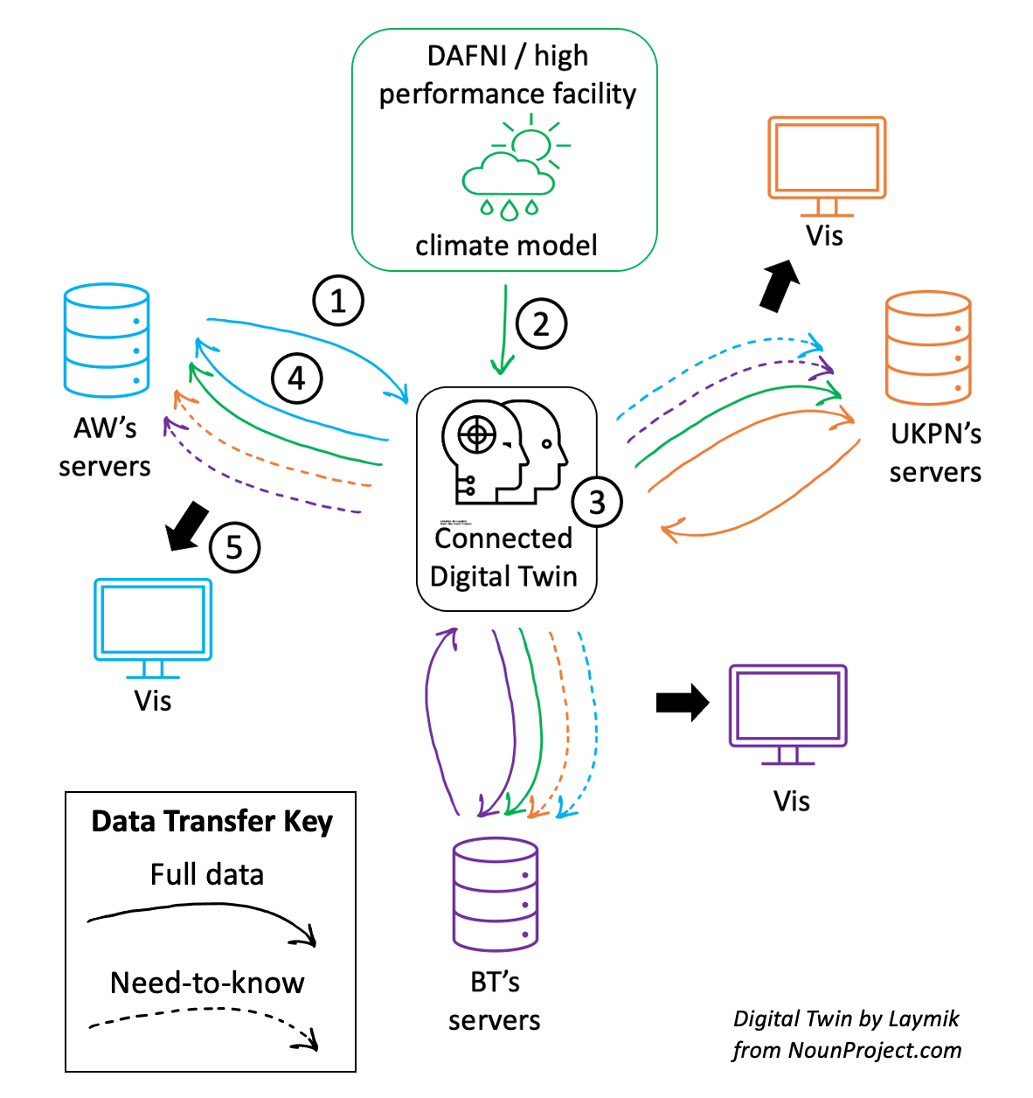
Figure 3: Illustrative diagram of the proposed distributed data architecture with permissions-based data access. The workflow is enumerated as follows: (1) asset owner data is collated at a central secure location, which hosts the connected digital twin; (2) climate simulations are run at high performance computing facilities and the results are retrieved by the digital twin; (3) asset and network failure models are computed, based on climate scenario; (4) results distributed to asset owners, and are restricted to need-to-know information for external asset data, see data transfer key; (5) visualisation use this combined data, so are different for each asset owner.
Knowledge sharing and public dissemination
In addition to the engineering tasks described above it is expected that the supplier might:
- Document their progress, learnings and proposed next steps in a public technical report and contribute to any other report writing.
- Contribute to webinars and presentations to various stakeholder groups.
- Contribute to a dissemination video that showcases CReDo.

Appendix 3: RESPONSE TO QUALITY EVALUATION CRITERIA

Tenderers can use the template below for their response to quality evaluation criteria. Responses in other formats are acceptable but must clearly address all quality evaluation criteria. Failure to address all criteria may result in the response being disregarded by CPC. No value is placed on answer word count, but answers exceeding 10% of the maximum word count may be disregarded by CPC. Any tables or diagrams and their captions do not contribute to the word count.
Criterion | Technical expertise and relevant prior experience  Using at least three examples of relevant prior work, please demonstrate the capabilities and experience that you will bring to the project.  If possible, please demonstrate technical capability of:  - Working with and cleaning: large datasets, geospatial data, critical infrastructure data, climate data.  - Developing: web applications, scientific visualisations, geospatial visualisations, analytical dashboards, and user interfaces.  - Developing in collaborative and remote environments.  - Developing modular and containerised solutions.  - Writing scalable code that follows best practices for documentation, maintenance and open source.  - Database concepts, database architectures, design principles, and graph data structures.  - Creating data and data pipelines for use within digital twins.  If possible, please showcase experience of:  - Working with industry partners, especially asset and infrastructure owners.  - Working in research, innovation, or with academics.  - Working in multidisciplinary teams.  - Working in climate resilience and adaptation or related areas.  - Contributing to knowledge sharing through presentations and webinars, technical reports.
Response

(Maximum 2,500 words)
Criterion | Appropriate and realistic project plan  Please outline how you will approach the work, including any risks, dependencies and milestones for progress control. Please explain explicitly how you will manage the uncertain nature of the technical specification at this stage and highlight what input you will need from the CPC or other partners to support that approach.  Please include a Gantt chart (or equivalent graphic representation of your project plan).
Response

(1,500 words excluding Gantt chart / graphic)
Criterion | Quality of the team  Please explain who will deliver the work and how the team will be managed. Please include specific roles that the team members will have in the project and the expected level of contribution for each role. Highlight any team members that are essential for successful delivery and explain your mitigation plans for any unplanned absences.
Response

(Maximum 1,000 words)
Criterion | Proposed approach to long-term exploitation of results  Please outline how this project fits with your own strategy and how you intend to exploit the results of this project to stimulate your company’s growth. Please include any dependencies on the CPC or the partners in this project, including (if appropriate) IP considerations.
Response

(Maximum 1,500 words)

Appendix 4: PRICING SCHEDULE

Please provide a breakdown of your proposed costs.

